How To: Wireless iSOBOT with ESP8266

Charles Wood  
chawood@pdx.edu  
October 15, 2017

# Overview

The iSOBOT robots are small bipedal robots with a large number of commands/actions built-in. They are typically controlled with a remote but for the purposes of PSUs Robot Theater, an automated solution is required. To enable automated iSOBOT control, an ESP8266 wireless microcontroller (uC) was attached to the back. This uC listens for commands sent via HTTP POST requests and converts them to the proper infrared (IR) signals to tell the iSOBOT which command to perform. Multiple iSOBOTs can be controlled simultaneously by connecting them all to the same wireless network and sending POST requests to the individual IPs. This document details how to set up your iSOBOT to work in this fashion.

# Requirements

1. iSOBOT
2. ESP8266 module. Used in this tutorial – ESP-12E, available on [Amazon](https://www.amazon.com/HiLetgo-Internet-Development-Wireless-Micropython/dp/B010O1G1ES/ref=sr_1_1?ie=UTF8&qid=1508114478&sr=8-1&keywords=hiletgo+new+version+esp8266) for $8.79 as of this writing.
3. 1x 1K resistor
4. 1x IR Emitter diode (EPL sells them)
5. Python (minimum 2.7)
6. Computer with Arduino v1.6 or greater installed
7. [Python & Arduino/ESP8266 code repo](https://github.com/imchipwood/iSOBOT_ESP8266)

# Setting up

## Software

1. [Install Arduino software](https://www.arduino.cc/en/Main/Software), recommend latest version but anything >=1.6 will do
2. Add ESP8266 support to Arduino – [follow this Adafruit guide](https://learn.adafruit.com/adafruit-huzzah-esp8266-breakout/using-arduino-ide).
3. Download or clone the [iSOBOT_ESP8266 repository](https://github.com/imchipwood/iSOBOT_ESP8266)
   1. iSOBOT #1 – WiFi_AP_STA. This first iSOBOT will create the wireless network for other iSOBOTs and your computer to connect to
      1. Open the ISOBOT_IR_WIFI_AP.ino Arduino sketch.
      2. Choose your board in the Tools->Board menu.
         1. The ESP8266 module linked above on Amazon is a “NodeMCU 1.0 (ESP-12E Module)”, and is what was left attached to the iSOBOTs when this document was written
      3. Compile the code – ensure no errors
      4. Connect the ESP8266 to your computer via USB
      5. Choose the correct port for programming the ESP8266 in Tools->Port
      6. Upload the code to the ESP8266
      7. Connect to the ESP8266 WiFi – “ESP8266 ISOBOT A” (password is ‘psuisobot’)
         1. If you can connect, the sketch is working
      8. The default IP address for this iSOBOT is 192.168.4.1
   2. iSOBOT #2 – WIFI_STA. This second iSOBOT is an example of controlling more than one iSOBOT over the same network
      1. Follow the same instructions for iSOBOT #1 but use the ‘ISOBOT_IR_WIFI_client.ino” Arduino sketch.
      2. Note that this iSOBOT will not be usable unless the other iSOBOT running ISOBOT_IR_WIFI_AP.ino is already powered on.
      3. The default IP address for this iSOBOT is 192.168.4.2
   3. iSOBOT #3+
      1. To control more than two iSOBOTs, use “ISOBOT_IR_WIFI_client.ino” for all of them except the first iSOBOT and change the IP address every time you upload to a new ESP8266. Look for this line and change the fourth number:

IPAddress ip(192, 168, 4, 3);

* + 1. Basically, each ESP8266 needs a unique IP address, so you must change this variable such that no two ESP8266s have the same IP.
       1. NOTE: do not use the IP address 192.168.4.2 for any of the ESP8266s – this seems to be the only IP address available for laptops/computers/etc. so if you set an ESP8266 to 192.168.4.2, it will prevent your laptop from connecting

## Hardware

### ESP8266

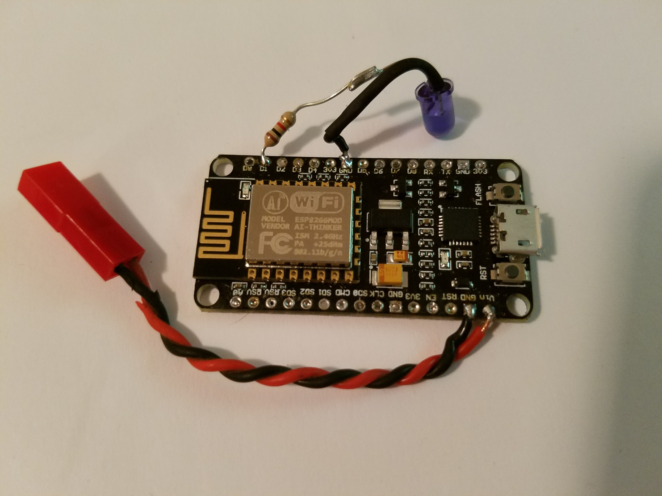

Figure 1. ESP8266 with IR emitter diode and power leads

If you purchased your ESP8266 from the [Amazon link](https://www.amazon.com/HiLetgo-Internet-Development-Wireless-Micropython/dp/B010O1G1ES/ref=sr_1_1?ie=UTF8&qid=1508114478&sr=8-1&keywords=hiletgo+new+version+esp8266) above, you may want to remove the pins from the ESP8266 module in order to make it more compact. Do so very carefully with a soldering iron as the board is small and it is very easy to overheat things. Remove 3 or 4 pins at a time and take breaks in between to ensure the board temperature does not reach dangerous levels.

Once all pins have been removed, solder power wires to the GND and VIN connections. Use 24ga wire or thicker to ensure sufficient current flow – ESP8266s are fairly low current devices, but better safe than sorry. Attach some sort of connector to allow easily removing the ESP8266 from the iSOBOT later.

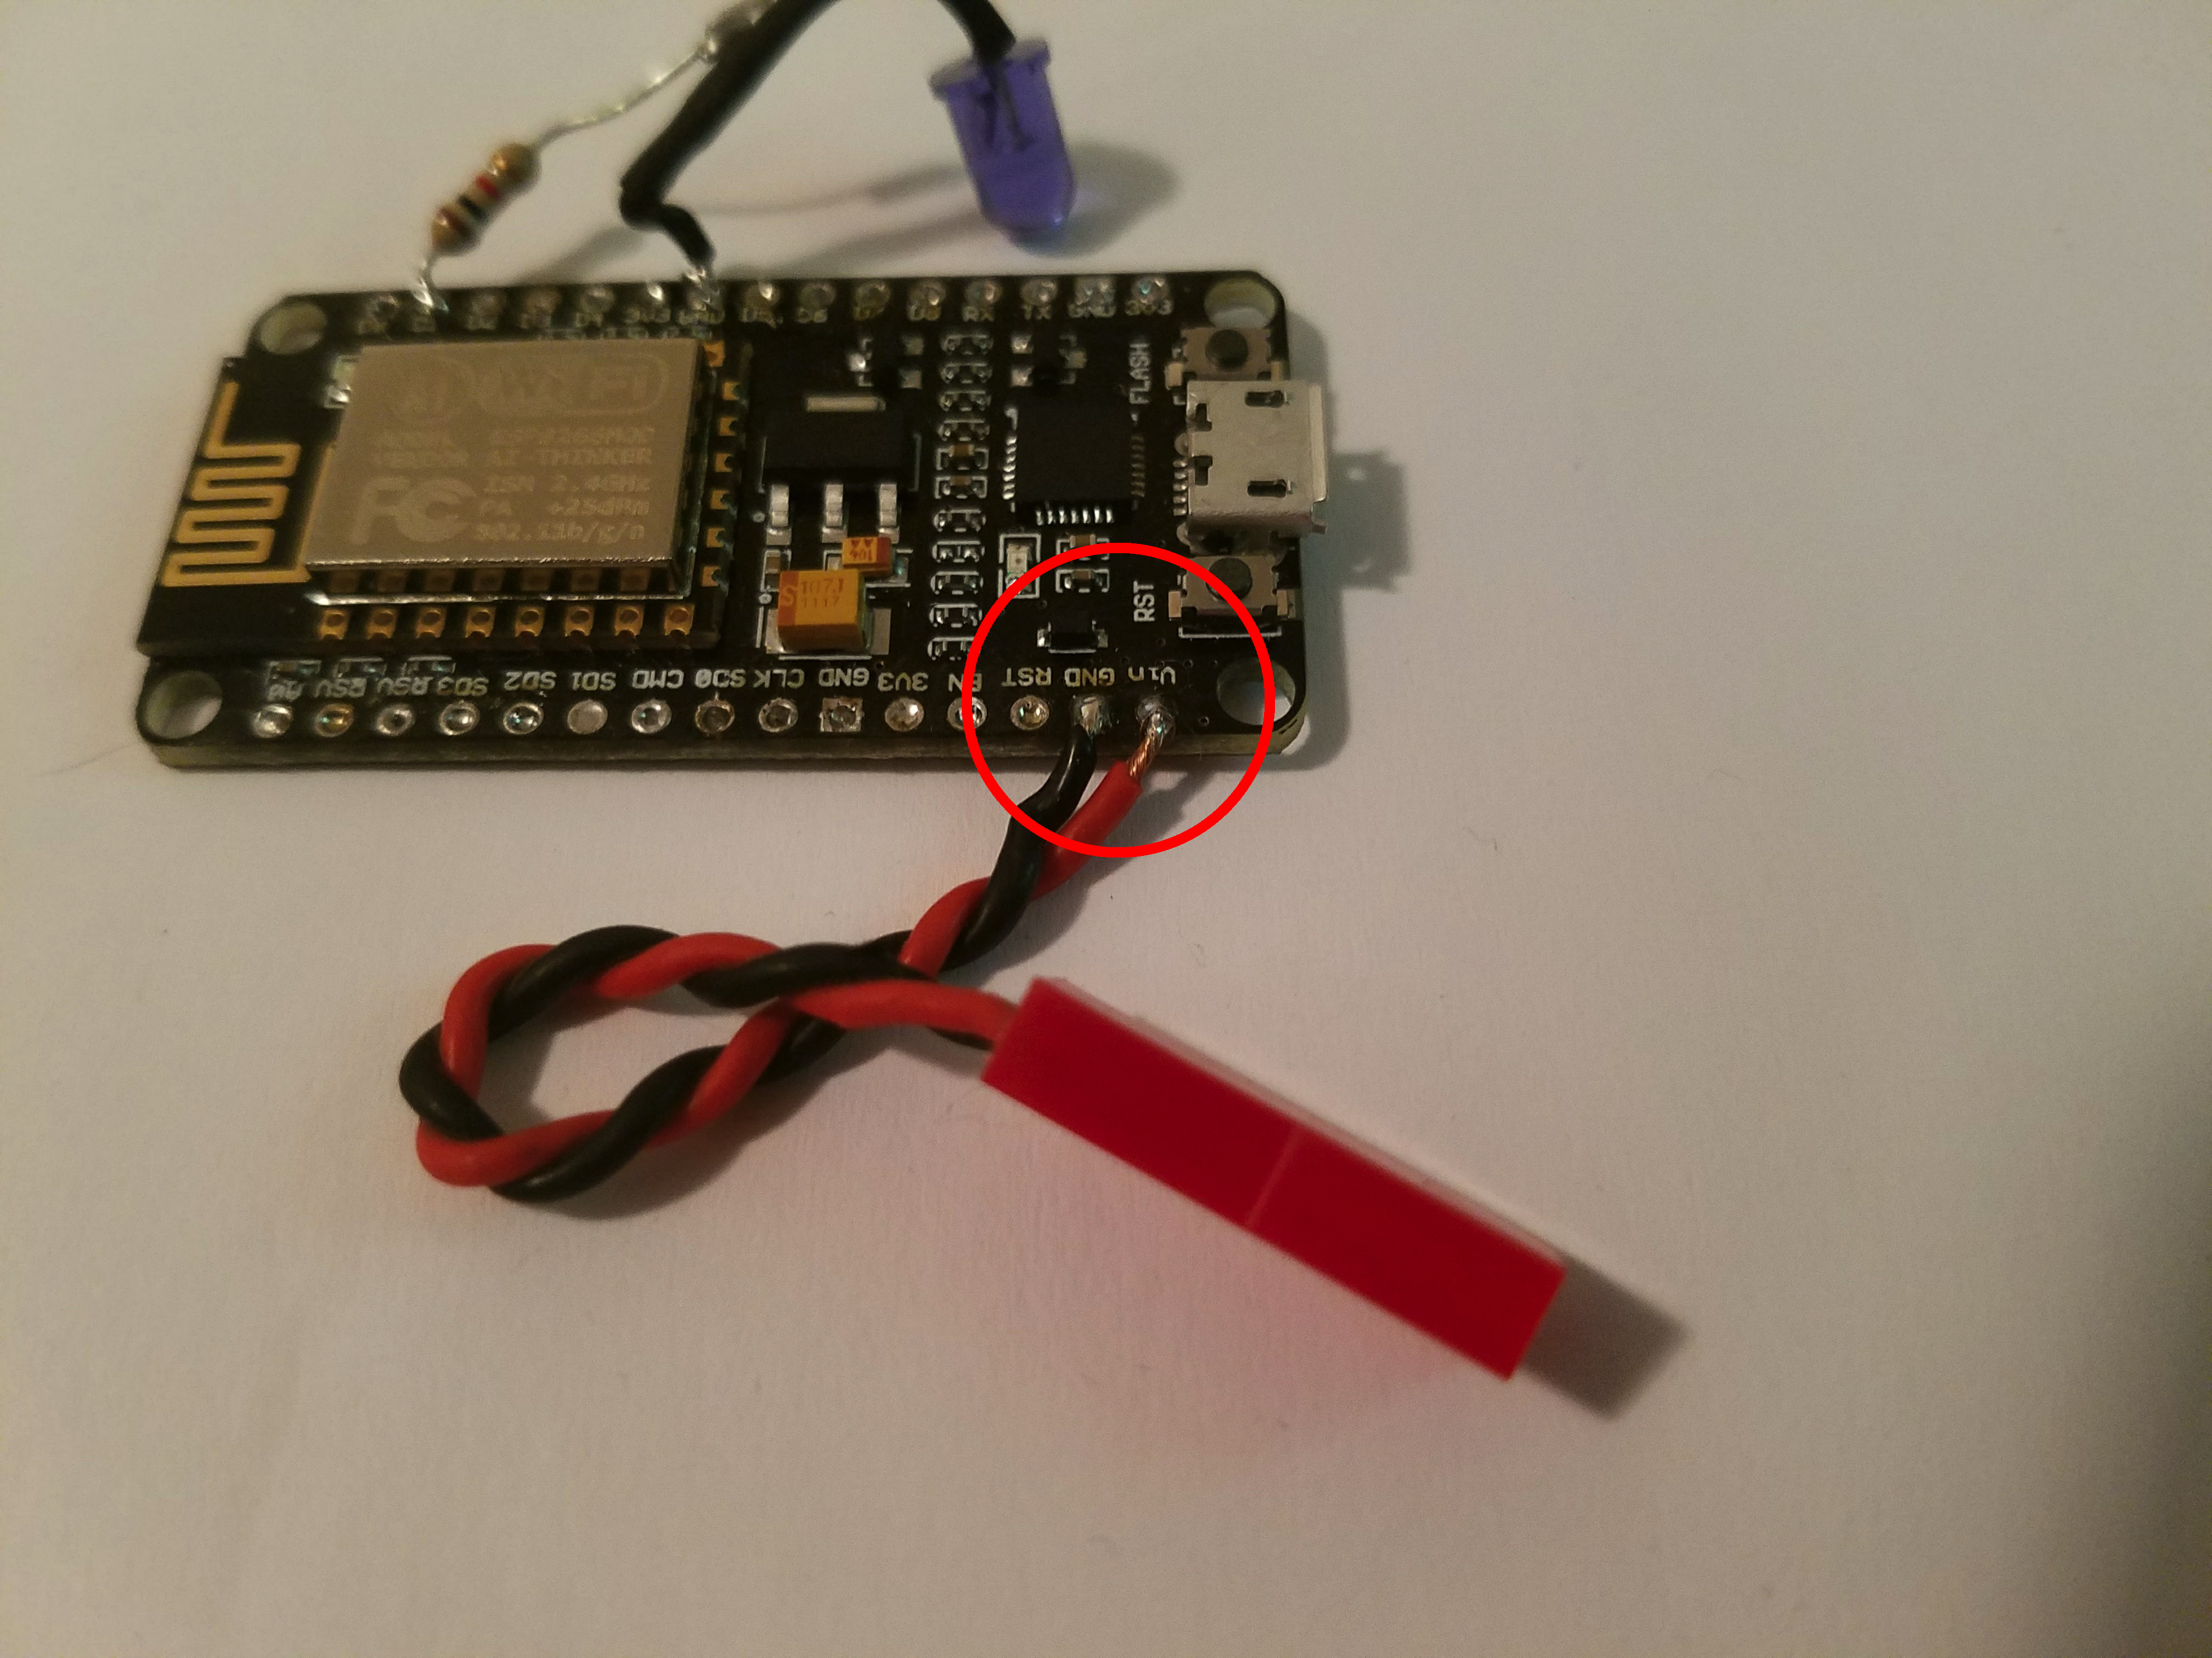

Figure 2. ESP8266 with wires attached to VIN & GND (circled in red) with attached mini-JST connector

Next, solder a resistor and IR emitter diode between D1 and GND as shown below. You may use a different IO port if you’d like, just make sure you change the ‘IR_TX_PIN’ variable in the Arduino sketches. Leave yourself enough room to bend the IR emitter towards the USB port - the diode needs to reach over and point at the IR receiver on the iSOBOT. If using extra wire, try to use single stranded wire such that the emitter diode does not flop around – you will need to point the diode at the IR receiver on the iSOBOT later when attaching the ESP8266.

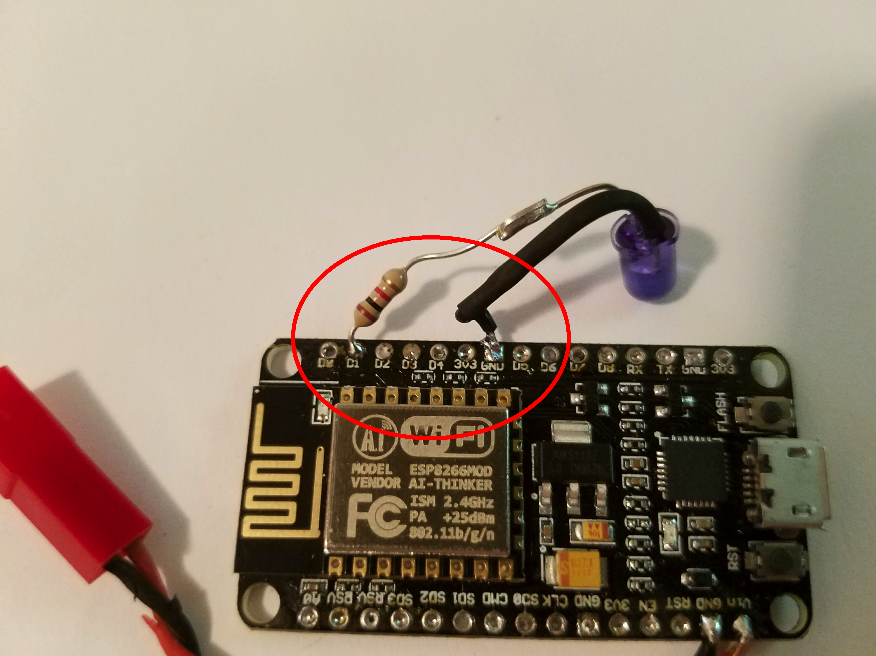

Figure 3. ESP8266 with IR emitter diode & current limiting 1K resistor

### iSOBOT

To control the iSOBOT, you will need to attach an ESP8266 to it. The iSOBOT does not have any external power connections to use, so you must open up the back and solder to the GND and VDD pads. The picture below shows some locations for easy connection:

<picture of inside of iSOBOT with highlighted VDD & GND pads>s

Figure 3. Internal view of rear of iSOBOT with GND and VDD wires attached

Remember to use the same type of connector you used earlier on the ESP8266 for the power wires.